**Use Case**

Actor Description

|  |  |
| --- | --- |
| **Actor Name** | **Actor Description** |
| Staff | **Including FT Staff, PT Staff and Cinema manger** |
| FT Staff | **Can handle sell ticket, food shop and scan ticket** |
| PT Staff | **Can handle all of thing except Account manager for staff** |
| Cinema manager | **Can handle all of things** |

# Cinema management system:

**(Punch in system)**

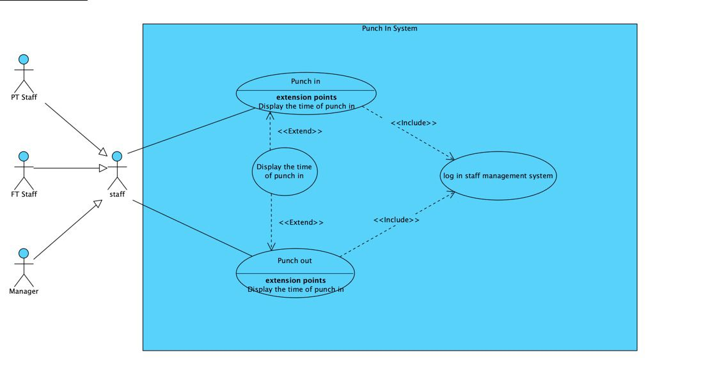

|  |
| --- |
| Use Case: Punch In |
| Use Case ID: UC-01 |
| Primary Actor: Staff |
| Case Description: Staff can Punch in before work |

|  |
| --- |
| Use Case: Punch out |
| Use Case ID: UC-02 |
| Primary Actor: Staff |
| Case Description: Staff can Punch out after work |

|  |
| --- |
| Use Case: Display the time of punch in/out |
| Use Case ID: UC-03 |
| Primary Actor: Staff |
| Case Description: Staff can view the time of punch in/out |

**(Food Shop) (Staff)**

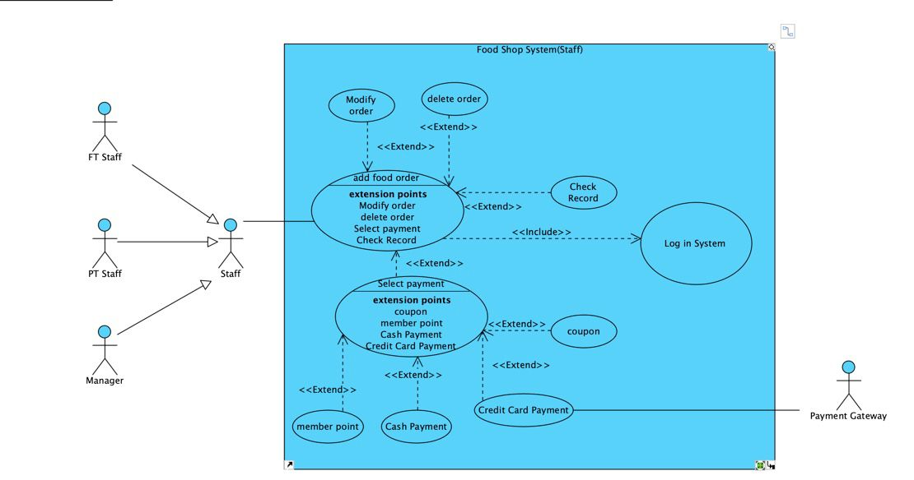

|  |
| --- |
| Use Case: Create food order |
| Use Case ID: UC-04 |
| Primary Actor: Staff |
| Case Description: Staff can assist customer order the food |

|  |
| --- |
| Use Case: Modify order |
| Use Case ID: UC-05 |
| Primary Actor: Staff |
| Case Description: Staff can modify order when the order have any question |

|  |
| --- |
| Use Case: Delete order |
| Use Case ID: UC-06 |
| Primary Actor: Staff |
| Case Description: Staff can delete the order |

|  |
| --- |
| Use Case: Check Record |
| Use Case ID: UC-07 |
| Primary Actor: Staff |
| Case Description: Staff can check all of the record about the order |

|  |
| --- |
| Use Case: Select Payment |
| Use Case ID: UC-08 |
| Primary Actor: Staff |
| Case Description: Staff can assist customer to pay the order by different payment |

**(Ticket)(Staff)**

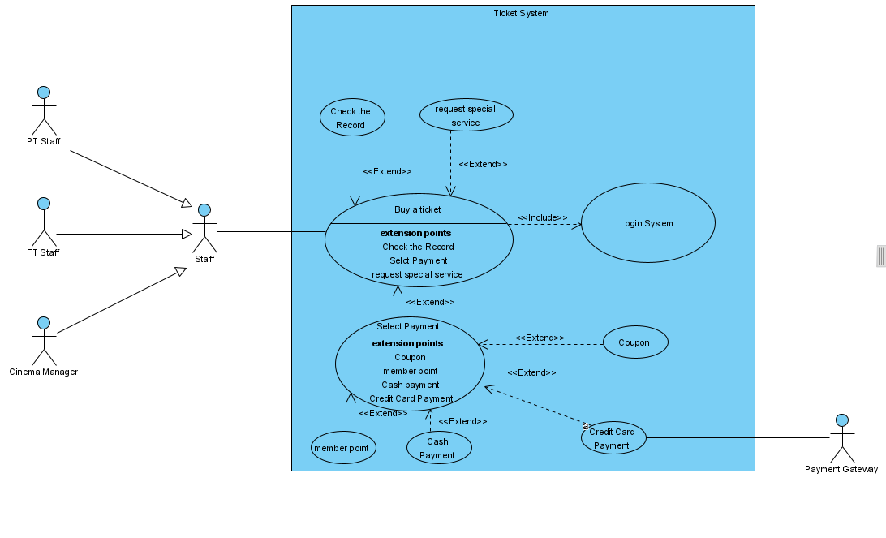

|  |
| --- |
| Use Case: Buy a ticket |
| Use Case ID: UC-09 |
| Primary Actor: Staff |
| Case Description: Staff can assist customer buy a ticket |

|  |
| --- |
| Use Case: request special service |
| Use Case ID: UC-10 |
| Primary Actor: Staff |
| Case Description: Staff can assist customer to request special service |

|  |
| --- |
| Use Case ID: UC-011 |
| Primary Actor: Staff |
| Case Description: Staff can check all of the record about the ticket record |

|  |
| --- |
| Use Case: Select Payment |
| Use Case ID: UC-08a |
| Primary Actor: Staff |
| Case Description: Staff can assist customer to pay the ticket by different payment |

**(Cinema management)**

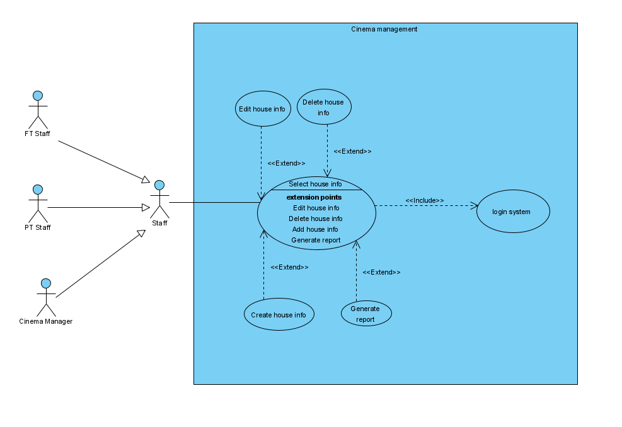

|  |
| --- |
| Use Case: Select house info |
| Use Case ID: UC-12 |
| Primary Actor: Staff |
| Case Description: Staff can select the house to modify the Screenings |

|  |
| --- |
| Use Case: Delete house info |
| Use Case ID: UC-10 |
| Primary Actor: Staff |
| Case Description: Staff can delete the Screening when the movie has been off the screen |

|  |
| --- |
| Use Case: Edit house info |
| Use Case ID: UC-11 |
| Primary Actor: Staff |
| Case Description: Staff can edit the house info |

|  |
| --- |
| Use Case: Create house info |
| Use Case ID: UC-12 |
| Primary Actor: Staff |
| Case Description: Staff can create house info before the movie release data |

|  |
| --- |
| Use Case: Edit house info |
| Use Case ID: UC-13 |
| Primary Actor: Staff |
| Case Description: Staff can edit the house info |

**(Movie info management)**

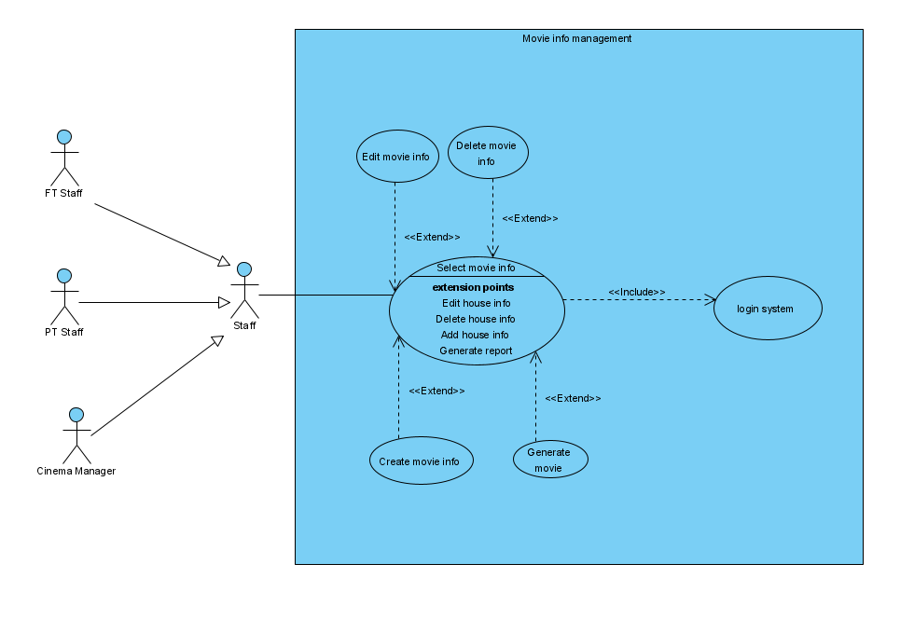

|  |
| --- |
| Use Case: Select movie info |
| Use Case ID: UC-12 |
| Primary Actor: Staff |
| Case Description: Staff can select the movie to modify the details |

|  |
| --- |
| Use Case: Delete movie info |
| Use Case ID: UC-13 |
| Primary Actor: Staff |
| Case Description: Staff can delete the info when the movie has been off the screen |

|  |
| --- |
| Use Case: Edit movie info |
| Use Case ID: UC-14 |
| Primary Actor: Staff |
| Case Description: Staff can edit the movie info |

|  |
| --- |
| Use Case: Create movie info |
| Use Case ID: UC-15 |
| Primary Actor: Staff |
| Case Description: Staff can create movie info before the movie release data |

|  |
| --- |
| Use Case: Edit house info |
| Use Case ID: UC-16 |
| Primary Actor: Staff |
| Case Description: Staff can edit the movie info |

**(Account management)**

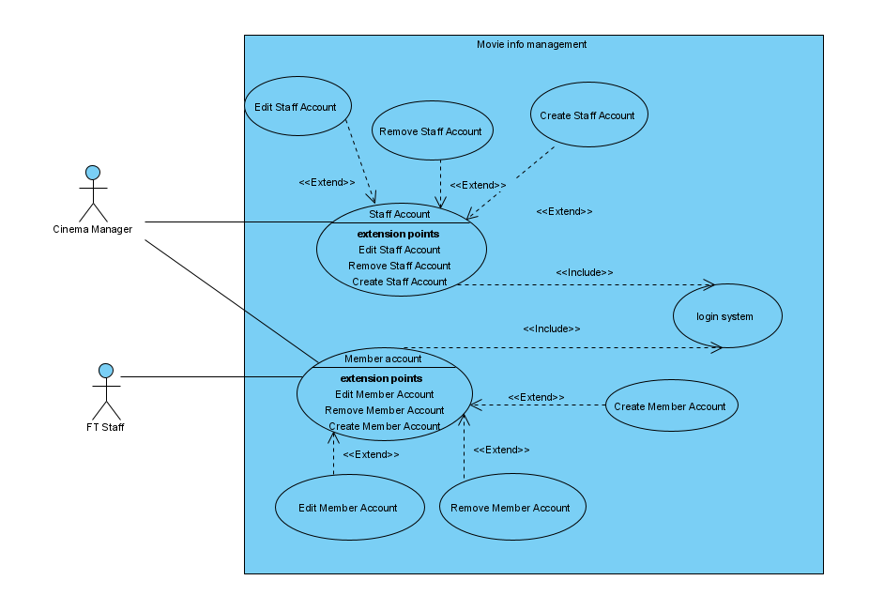

|  |
| --- |
| Use Case: Staff account |
| Use Case ID: UC-17 |
| Primary Actor: Cinema manager |
| Case Description: Cinema manager can select the staff account to modify the details |

|  |
| --- |
| Use Case: Delete Staff account |
| Use Case ID: UC-18 |
| Primary Actor: Cinema manager |
| Case Description: Cinema manager can delete staff account |

|  |
| --- |
| Use Case: Edit Staff account |
| Use Case ID: UC-19 |
| Primary Actor: Cinema manager |
| Case Description: Cinema manager can edit the staff account |

|  |
| --- |
| Use Case: Create Staff account |
| Use Case ID: UC-20 |
| Primary Actor: Cinema manager |
| Case Description: Cinema manager create staff account |

|  |
| --- |
| Use Case: Customer account |
| Use Case ID: UC-21 |
| Primary Actor: Cinema manager, FT Staff |
| Case Description: Cinema manager can select the customer account to modify the details |

|  |
| --- |
| Use Case: Delete Staff account |
| Use Case ID: UC-22 |
| Primary Actor: Cinema manager, FT Staff |
| Case Description: Cinema manager can delete customer account |

|  |
| --- |
| Use Case: Edit Staff account |
| Use Case ID: UC-23 |
| Primary Actor: Cinema manager, FT Staff |
| Case Description: Cinema manager can edit the customer account |

|  |
| --- |
| Use Case: Create Staff account |
| Use Case ID: UC-24 |
| Primary Actor: Cinema manager, FT Staff |
| Case Description: Cinema manager create customer account |

**(Scan ticket)**

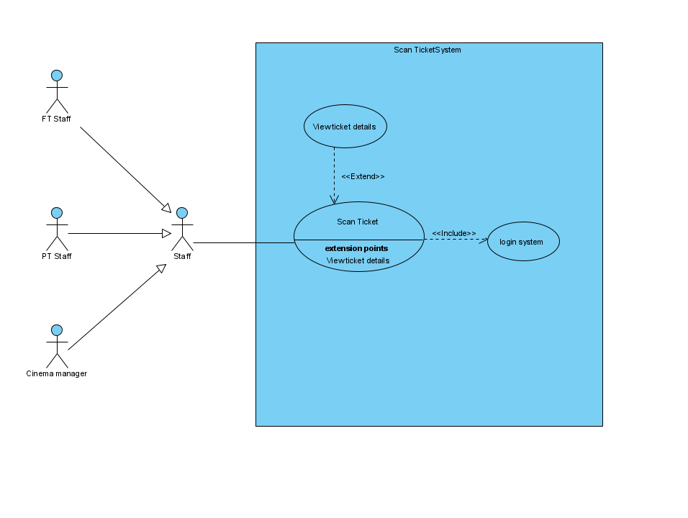

|  |
| --- |
| Use Case: Scan ticket |
| Use Case ID: UC-25 |
| Primary Actor: Staff |
| Case Description: Staff can scan the ticket to check the ticket invalid |

|  |
| --- |
| Use Case: View ticket details |
| Use Case ID: UC-26 |
| Primary Actor: Staff |
| Case Description: Staff can view the details after scan successful |

**Class Diagram**

**(Punch in)**

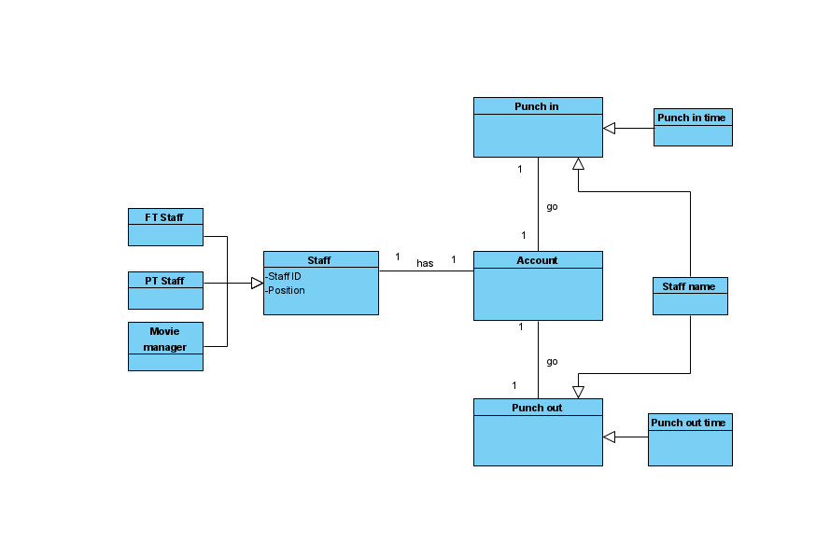

**(Food Shop) (Staff)**

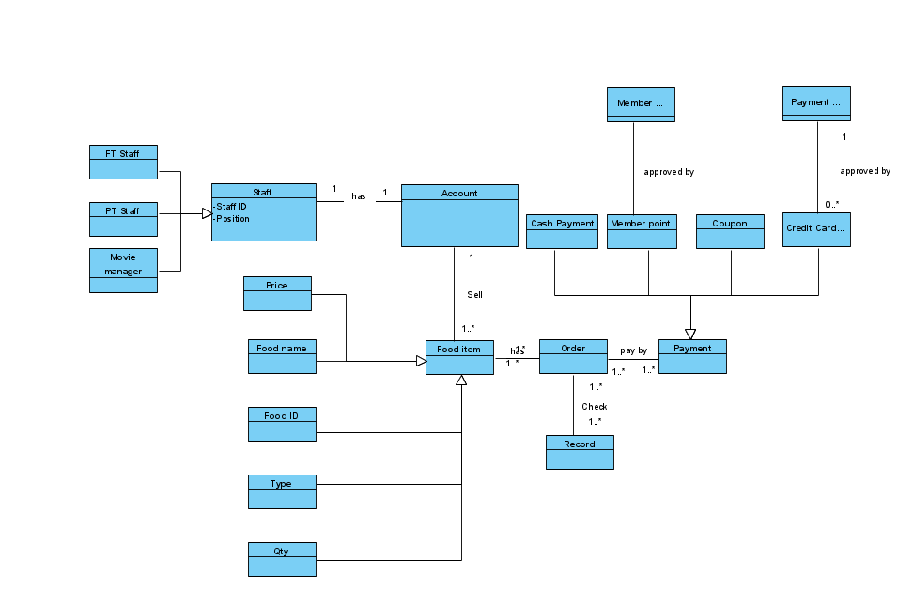

**(Ticket System) (Staff)**

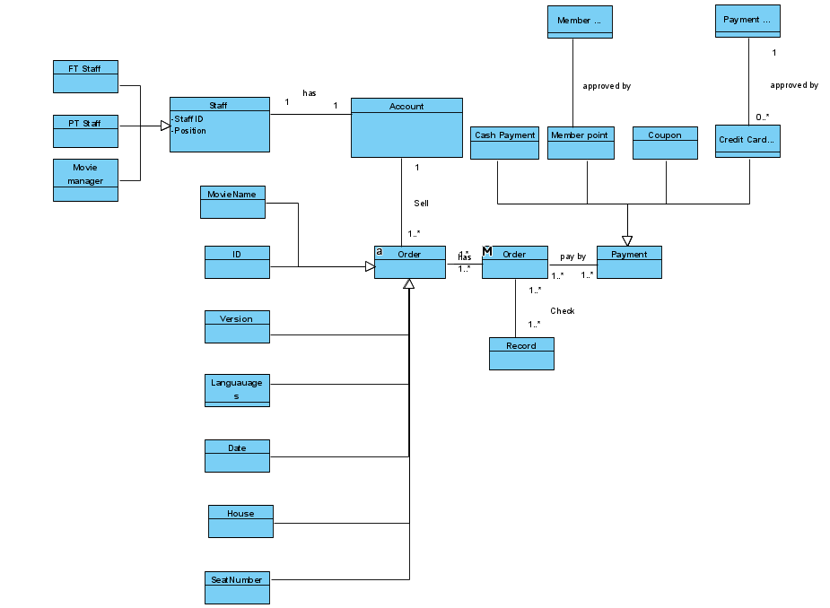

**(Cinema management)**

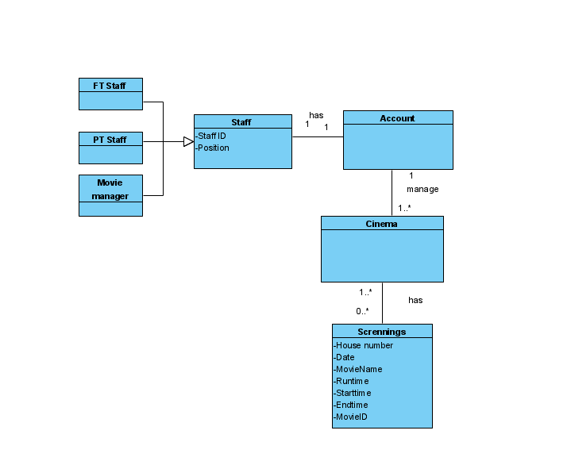

**(Movie info management)**

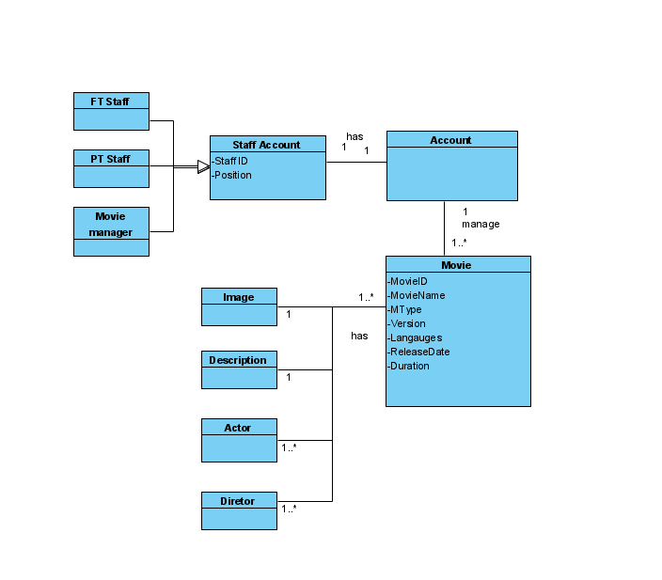

**(Account management)**

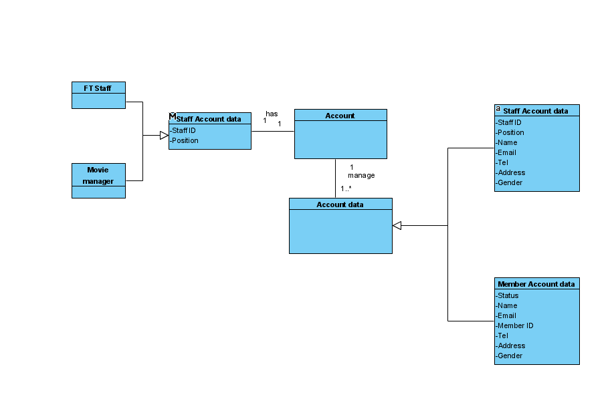

**(Scan ticket)**

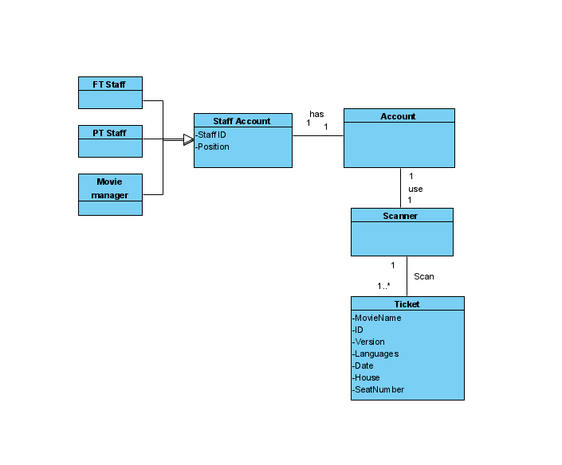

# Sequence Diagram

**(Punch in system)**

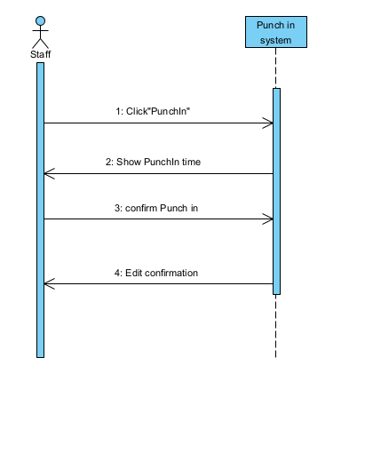

**(Food Shop) (Staff)**

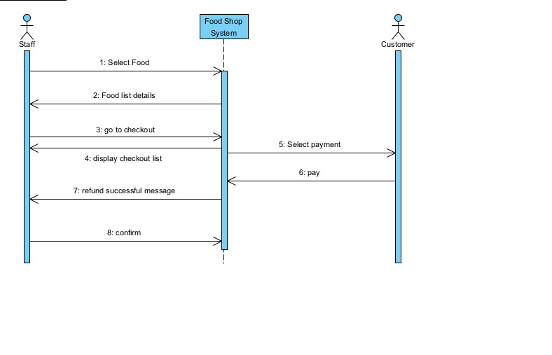

**(Ticket)(Staff)**

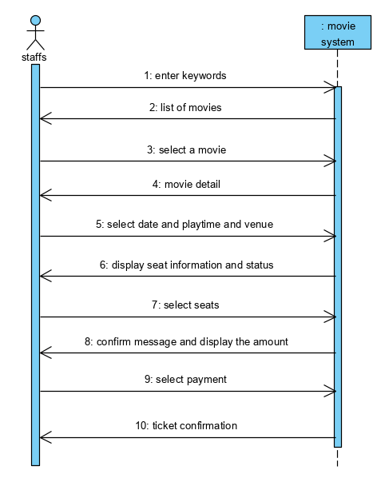

**(Cinema management)**

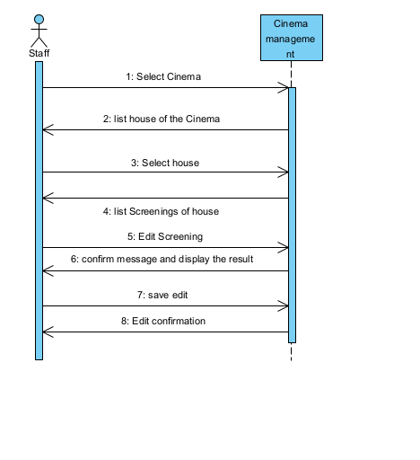

**(Movie info management)**

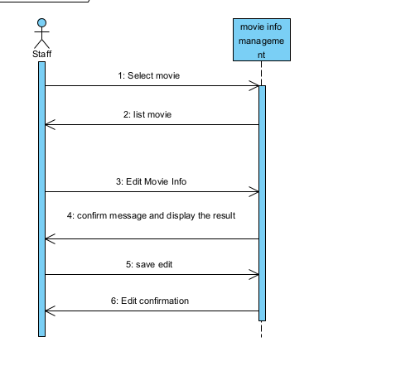

**(Account management)**

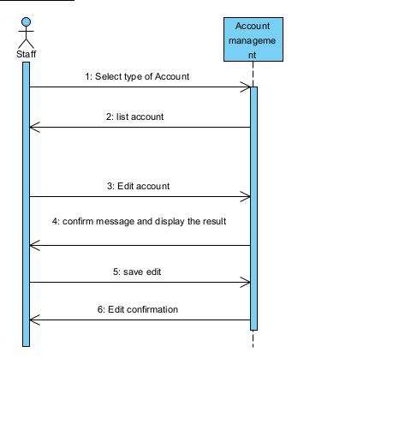

**(Scan ticket)**

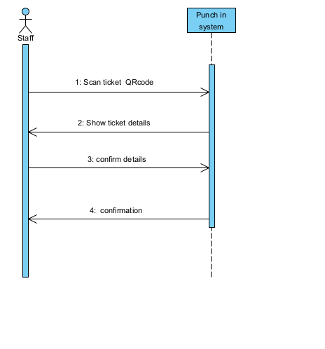

**3tier**

**(Punch in)**

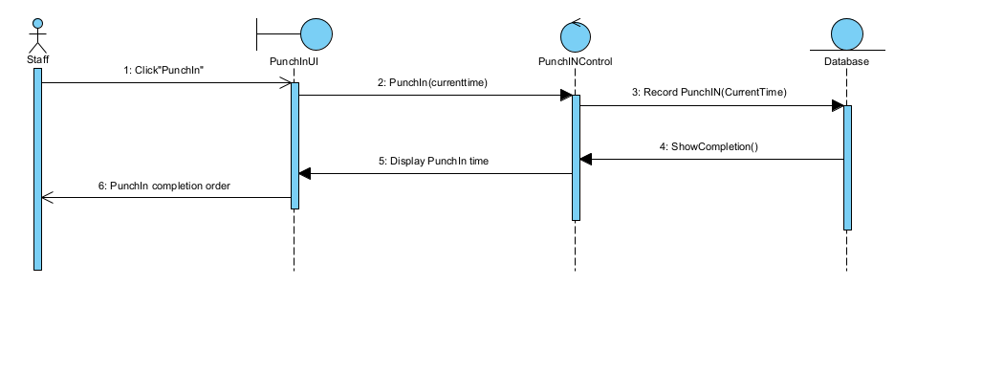

**(Food Shop) (Staff)**

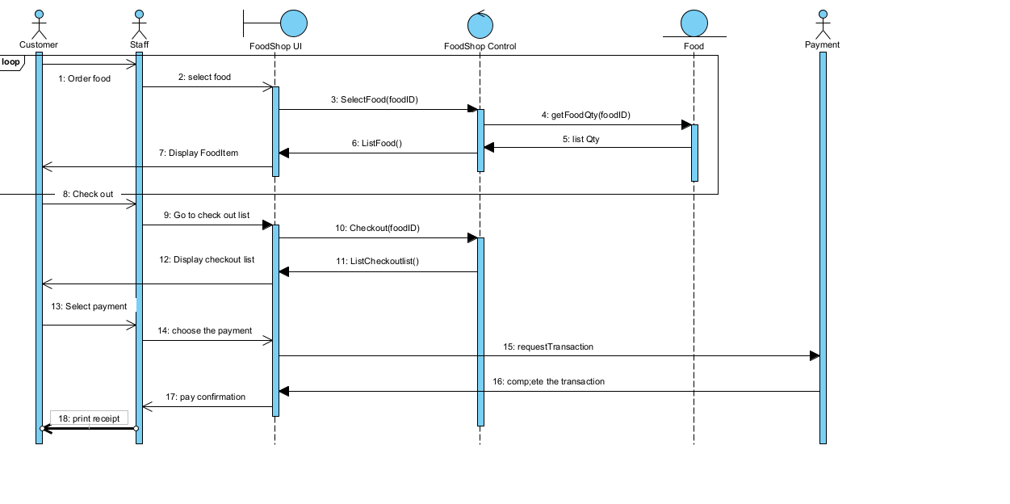

**(Ticket)(Staff)**

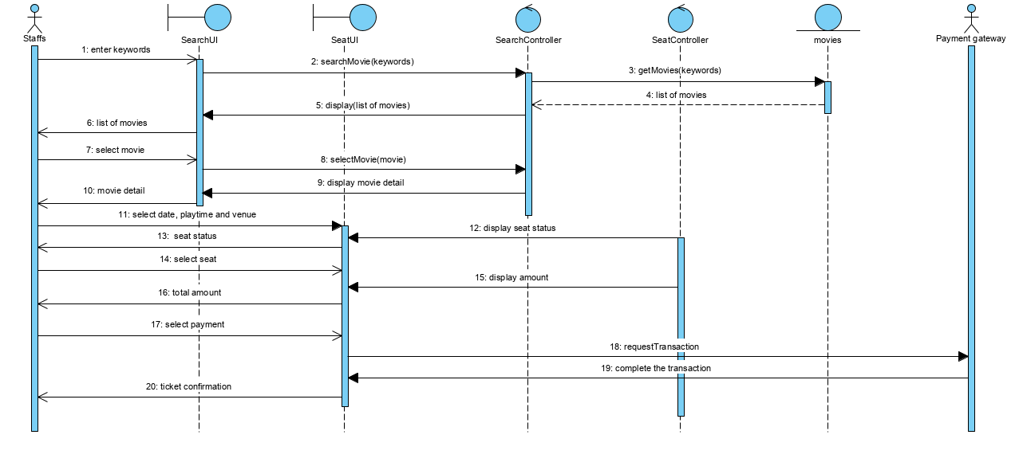

**(Cinema management)**

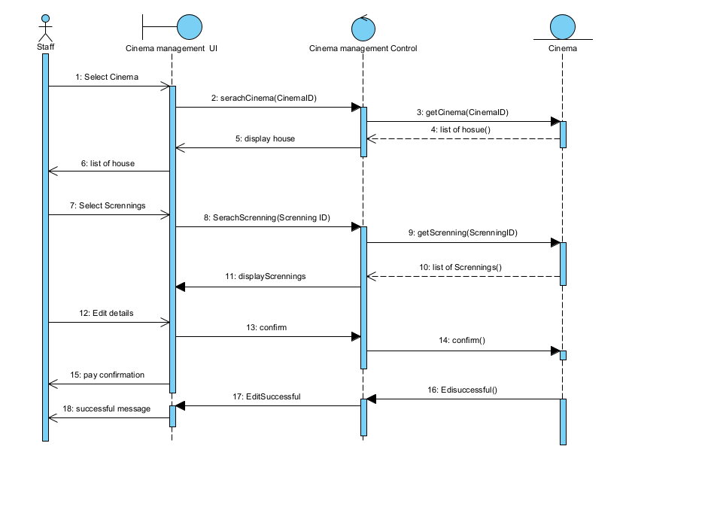

**(Movie info management)**

**(Account management)**

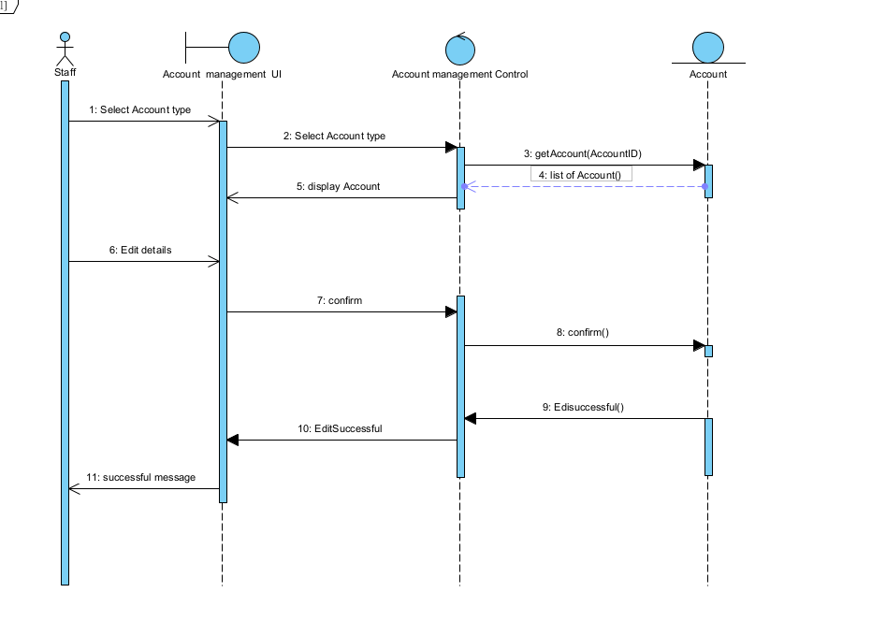

**(Scan ticket)**

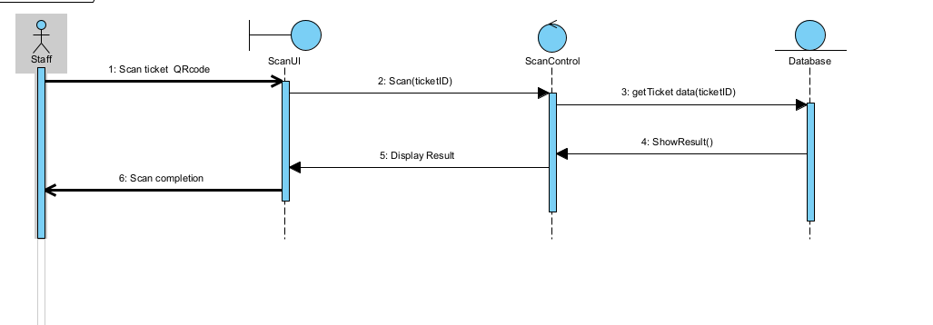

**State machine diagram**

**(Punch in)**

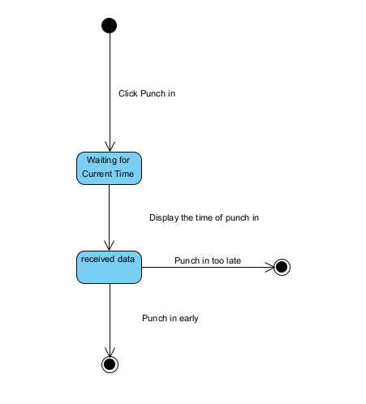

**(Food Shop) (Staff)**

**(Ticket)(Staff)**

**(Cinema management)**

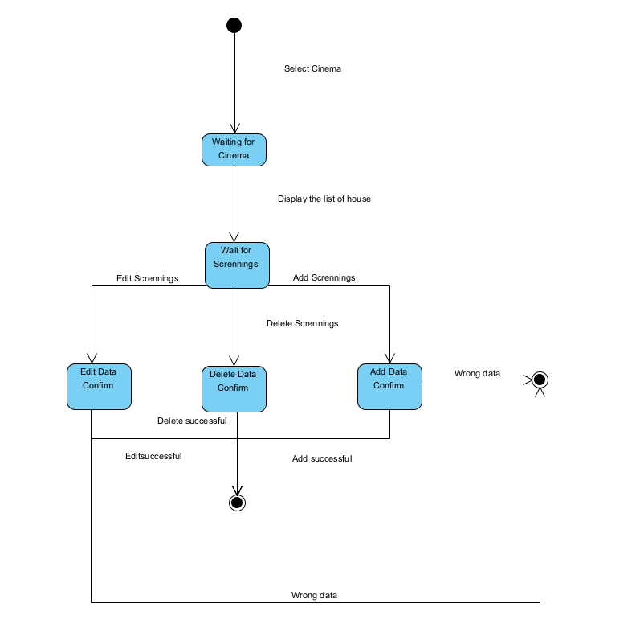

**(Movie info management)**

**(Account management)**

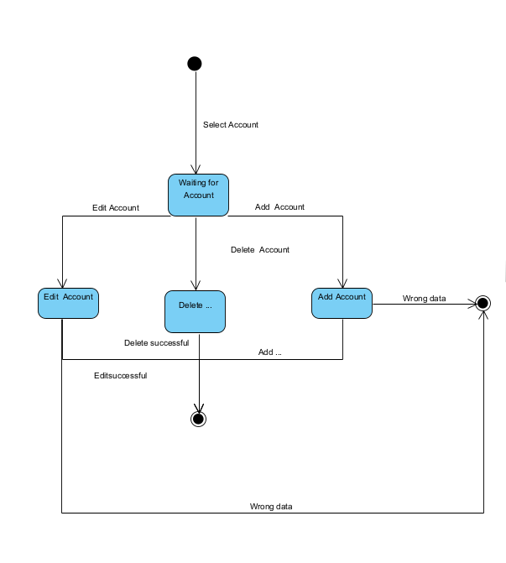

**(Scan ticket)**

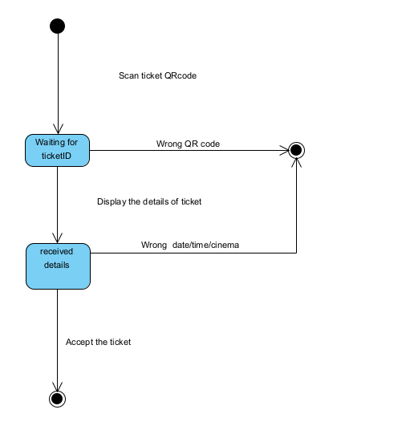

**UI**

**Staff login Page**

**The login page of the staff login. When staff login to the system,**

